|  |
| --- |
|  |
| 新概念 3 册 |
| Lesson38 |

Lesson 38 The first calendar

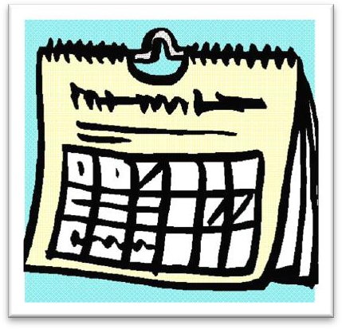

**calendar ['kælɪndə(r)]**

**n. 日历**

solar calendar lunar calendar Chinese calendar perpetual calendar desk calendar

wall calendar

unique [ju'ni:k]

**adj. 唯一的，独一无二的**

a unique position

Each person’s DNA is unique. be unique to ...

Fingerprints are unique to every individual. be peculiar to ...

Pandas are peculiar to China. be confined to ...

..., for collectors are not confined to any one country. be limited to ...

The air strikes are limited to military targets. be restricted to ...

Access to the company files is restricted to management.

solely ['səʊlli] adv. 唯一地sole

He is the sole survivor of the car accident. only single

... to this day it has never written a single word. lone solitary

Owen scored the lone goal of the match. They had a single aim, a solitary goal, the top.

bewilder [bɪ'wɪldə(r)]

**v. 令人眼花缭乱，晕头转向**

Big city traffic bewildered the country girl. bewildering

the bewildering amount of information confuse

They confused me with their conflicting advice. confusing

Many tourists were by the city’s complicated traffic system.

(A) degraded (B) bewildered

(C) evoked (D) diverted

As an increasing number of traffic regulation schemes are devised, the poor bewildered driver finds himself diverted and forced into one-way systems which cause even greater delays than the traffic jams they are supposed to prevent.

puzzle perplex baffle

The murder case still puzzled / perplexed / baffled the police. puzzling perplexing baffling

deduce [dɪ'dju:s]

**v. 推理，推断**

deduce ... from ...

I can deduce his motives from his behavior. deduction

conclude ... from ...

What do you conclude from the evidence? conclusion

infer ... from ...

What can we infer from the passage? inference

scanty ['skænti]

**adj. 不足的，匮乏的**

scanty clues scanty evidence

scant insufficient inadequate

sufficient adequate scarce

Food and clean water were becoming scarce. rare a rare disease / species

sparse a sparse population sparsely-populated regions

be deficient in ...

a diet deficient in vitamin C be few and far between

People like John are few and far between.

Thank God people like John are few and far between.

engrave [ɪn'greɪv]

**v. 雕刻**

Historians have long been puzzled by dots, lines and symbols which have been engraved on walls, bones, and the ivory tusks of mammoths.

inscribe

At the base of the gold cap, the words 'made in the U.S.A' had been neatly inscribed. sculpt sculpture

etch

be etched / engraved on / in one’s memory

The scene will be etched / engraved on / in my memory forever.

correlate ['kɒrəleɪt]

**v. 使相互联系**

Stress levels and heart disease are strongly correlated. relate

Cancer cases in the area are directly related to the new nuclear power station. correlation

There’s a high correlation between smoking and lung cancer. husband-to-be fiancé

bride-to-be fiancée

posterity

These works of art are preserved for posterity. in the near / not-too-distant future

in the foreseeable future in the long run

in the short run

Taking this decision will cost us more in the short run, but will be beneficial in the long run. modern historians

today’s historians historians of today contemporary historians position: situation

She’s in the enviable position of being able to choose who she works with. When two of your best friends argue it puts you in a very awkward position. in a delicate position

in a dominating position in a favorable position in an adverse position China’s world position come to do sth.

I’ve come to like her over the months.

A body came to be found under the bridge.

造句: 在计算机的帮助下,当代的科学家在开始进行复杂运算的时候处于得天独厚的地位。

With the assistance of computers, contemporary scientists are in a unique position when they

come to make complicated calculations.

They will hardly know which facts to select *from the great mass of evidence that steadily accumulates*.

“疑问词 + to do”可以视为名词性从句的缩略形式

1、相当于宾语从句

They will hardly know which facts to select from …

➔ They will hardly know which facts they should select from … I don’t know what to do.

➔ I don’t know what I should do.

I haven't decided whether to sell it or not.

➔ I haven't decided whether I should sell it or not. Have you settled where to go?

➔ Have you settled where you should go? 2、相当于主语从句

Who to turn to is what she wants to know.

➔ Who she should turn to is what she wants to know. 3、相当于表语从句

The problem she faces is which way to take.

The problem she faces is which way she should take. 4、相当于同位语从句

The problem which course to take worried Lucy for hours.

The problem which course she should take worried Lucy for hours. mass: a large quantity or number

a mass of ... / masses of ...

= a lot of… / lots of …

the great mass of evidence

Traditional custom, taken the world over, is a mass of detailed behavior more astonishing than what any one person can ever evolve in individual actions, no matter how aberrant.

This caused the construction of gigantic buildings where too large masses of human beings are crowded together.

the masses

It is an entertainment that will appeal to the masses. mass education

the problem of mass unemployment weapons of mass destruction

mass communication

ever-doing adj. 不断……的

We have to ask ourselves very seriously what will happen if this two-fold use of knowledge with its ever-increasing power continues.

evidence that steadily accumulates the ever-accumulating evidence the world that steadily changes the ever-changing world

the knowledge that steadily grows the ever-growing knowledge

the economy that steadily develops the ever-developing economy

the market that steadily expands the ever-expanding market

the reform that steadily deepens the ever-deepening reform

the resources that steadily dwindle the ever-dwindling resources what is more / what’s more

He could not find his fifty pence piece anywhere, and what is more, he could not get his arm out. furthermore moreover besides

in addition additionally better still

worse still

to make things worse to make matters worse stranger still

During these tests she was able to read a newspaper through an opaque screen and, stranger still, by moving her elbow over a child's game of Lotto she was able to describe the figures and colours printed on it; …

rely on ... depend on ...

bank on ... count on ...

hinge on ... rest on ...

build on ... ride on ... reliance on …

the written word = written language a written agreement / statement the spoken word = spoken language oral / verbal

an oral exam

a verbal agreement as it were

He is, as it were, a walking dictionary.

Reading is thought to be a kind of conversation between the reader and the text. The reader puts questions, as it were, to the text and gets answers. In the light of these he puts further questions, and so on.

The Han nationality and the minority nationalities are all, as it were, members of the same family. so to speak

He is, so to speak, a walking dictionary.

The Han nationality and the minority nationalities are all, so to speak, members of the same family.

as it is

I thought things would get better, but as it is they are getting worse. His father told everybody that Eric had been killed in action.

But the historian attempting to reconstruct the distant past is always faced with a difficult task. reconstruct

When the archaeologists reconstructed the fragments, they were amazed to find that the goddess turned out to be a very modern-looking woman.

piece together

From this the captain was able to piece together all the information that had come to light. But the historian attempting to piece together the distant past ...

be faced with …

… for then man was faced with a real need to understand something about the seasons. They were expecting their sixth child and were faced with even more pressing economic problems.

After buying a new chain I was faced with the insurmountable task of putting the confusing jigsaw puzzle together again.

be confronted with ...

But if the animals are confronted with situations they have no control over, they later behave passively when faced with experiences they can control.

He has to deduce what he can *from the few scanty clues available*. the most democratic form of ‘college’ imaginable

the most civilized society conceivable the most talented person available the farthest star visible

We often read in novels how a seemingly respectable person or family has some terrible secret which has been concealed from strangers for years.

shed / throw / cast light on sth.

Figuring out how humans acquire language may shed light on why some children learn to read and write later than others.

Groundbreaking research by two French geophysicists promises to shed some light on the mystery.

come to light

From this the captain was able to piece together all the information that had come to light. One of the most colorful figures in boxing history was Daniel Mendoza, who was born in 1764. The devastating floods of two years ago pale in comparison with last week’s storms.

Up to now, historians have assumed *that calendars came into being with the advent of agriculture*, for then man was faced with a real need to understand something about the seasons.

come into being

To be or not to be, that is the question.

— William Shakespeare ‘Hamlet’ I think therefore I am.

come into being

come into fashion come into use come into effect come into blossom

the advent of sth. / sb.

The advent of the steam engine heralded the beginning of a new era. With the advent of the new chairman, the company began to prosper. with the advent of ...

with the coming / arrival of ... with the birth of ...

with the genesis of ... with the coming of spring

with the approach of Christmas with the outbreak of war

with the progress of science

with the evidence began to accumulate X

As the evidence began to accumulate, experts from the zoo felt obliged to investigate, … indicate

I shook my head and held up five fingers indicating that I was willing to pay￡5.

Historians have long been puzzled by dots, lines and symbols which have been engraved on walls, bones, and the ivory tusks of mammoths.

be puzzled by ... be perplexed by ... be baffled by ...

Doctors have long been puzzled by the rare skin condition.

It has long been known that the hunting scenes depicted on walls were not simply a form of artistic expression.

It has long been believed that cats have nine lives.

There has long been a superstition among mariners that porpoises will save drowning men by pushing them to the surface, or protect them from sharks by surrounding them in defensive formation.

ivory tower

a place or situation where you are separated from the difficulties of ordinary life and so are unable to understand them, used especially to describe a college or university

The nomads who made these markings lived by hunting and fishing *during the last Ice Age which began about 35,000 B.C. and ended about 10,000 B.C*.

live by doing sth.

It has been said that everyone lives by selling something. age

the Ice / Stone Age the modern age the computer age times

Roman times

in modern / recent / ancient / prehistoric times era / epoch

the steam-engine era / epoch the end of an era / epoch

His death marked the end of an era. the beginning of a new era / epoch

The foundation of the People’s Republic of China marked the beginning of a new era / epoch.

B.C. / BC Before Christ

A.D. / AD Anno Domini

造句：传说中道教的创始人老子，生活在大约公元前6 世纪至公元前5 世纪春秋时代的晚期， 靠掌管国家图书馆为生。

Laozi, legendary founder of Daoism, lived by taking charge of the royal library during the late Spring and Autumn Period which began about 600 B.C. and ended about 500 B.C.

By correlating markings made in various parts of the world, historians have been able to read this difficult code.

in various parts of the world

Cooked in wine, snails are a great luxury in various parts of the world.

They have found that it is connected with the passage of days and the phases of the moon. wax and wane

ebb and flow up and down to and fro

on and off

人有悲欢离合月有阴晴圆缺此事古难全 但愿人长久 千里共婵娟

With joy and woe people meet and part

With light and shade the moon waxes and wanes Since time immemorial it’s been unchanged Would that we could live a long life

And together share the moonlight though thousands of miles apart

It has long been known that the hunting scenes *depicted on walls* were not simply a form of artistic expression.

depict v. 1. 描绘，描画；2. 描写

a picture depicting him as a clown

The novel depicts French society in the 1930s.

They had a definite meaning, for they were as near *as early man could get to writing*. definite a definite meaning

a definite answer definite article

indefinite indefinite article

an indefinite prison term definitive

a definitive judgment a definitive diagnosis

a definitive guide book

finite Human knowledge is finite.

infinite The universe is infinite. infinitive

get to doing sth.=start doing sth.

He got to thinking that it was all his fault.

It is possible that there is a definite relation *between these paintings and the markings that sometimes accompany them*.

Having left the bag in the hall, I accompanied Robert into the living room. The disease is accompanied by sneezing and fever.

Chinese President Xi Jinping, accompanied by his wife Peng Liyuan, is undertaking a state visit to the United Sates.

It seems that man was making a real effort to understand the seasons *20,000 years earlier than has been supposed*.

make an effort to do sth. spare no effort to do sth.

China will spare no effort to realize peaceful reunification.

... than what has been supposed.

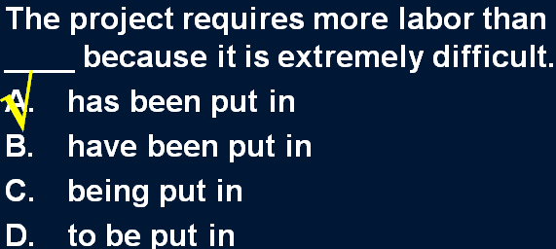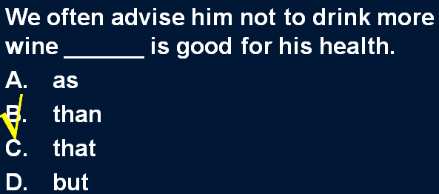To compensate for his unpleasant experiences in hospital, the man drank a little more than was good for him.

